­

**KAMAL KUMAR SWAIN**

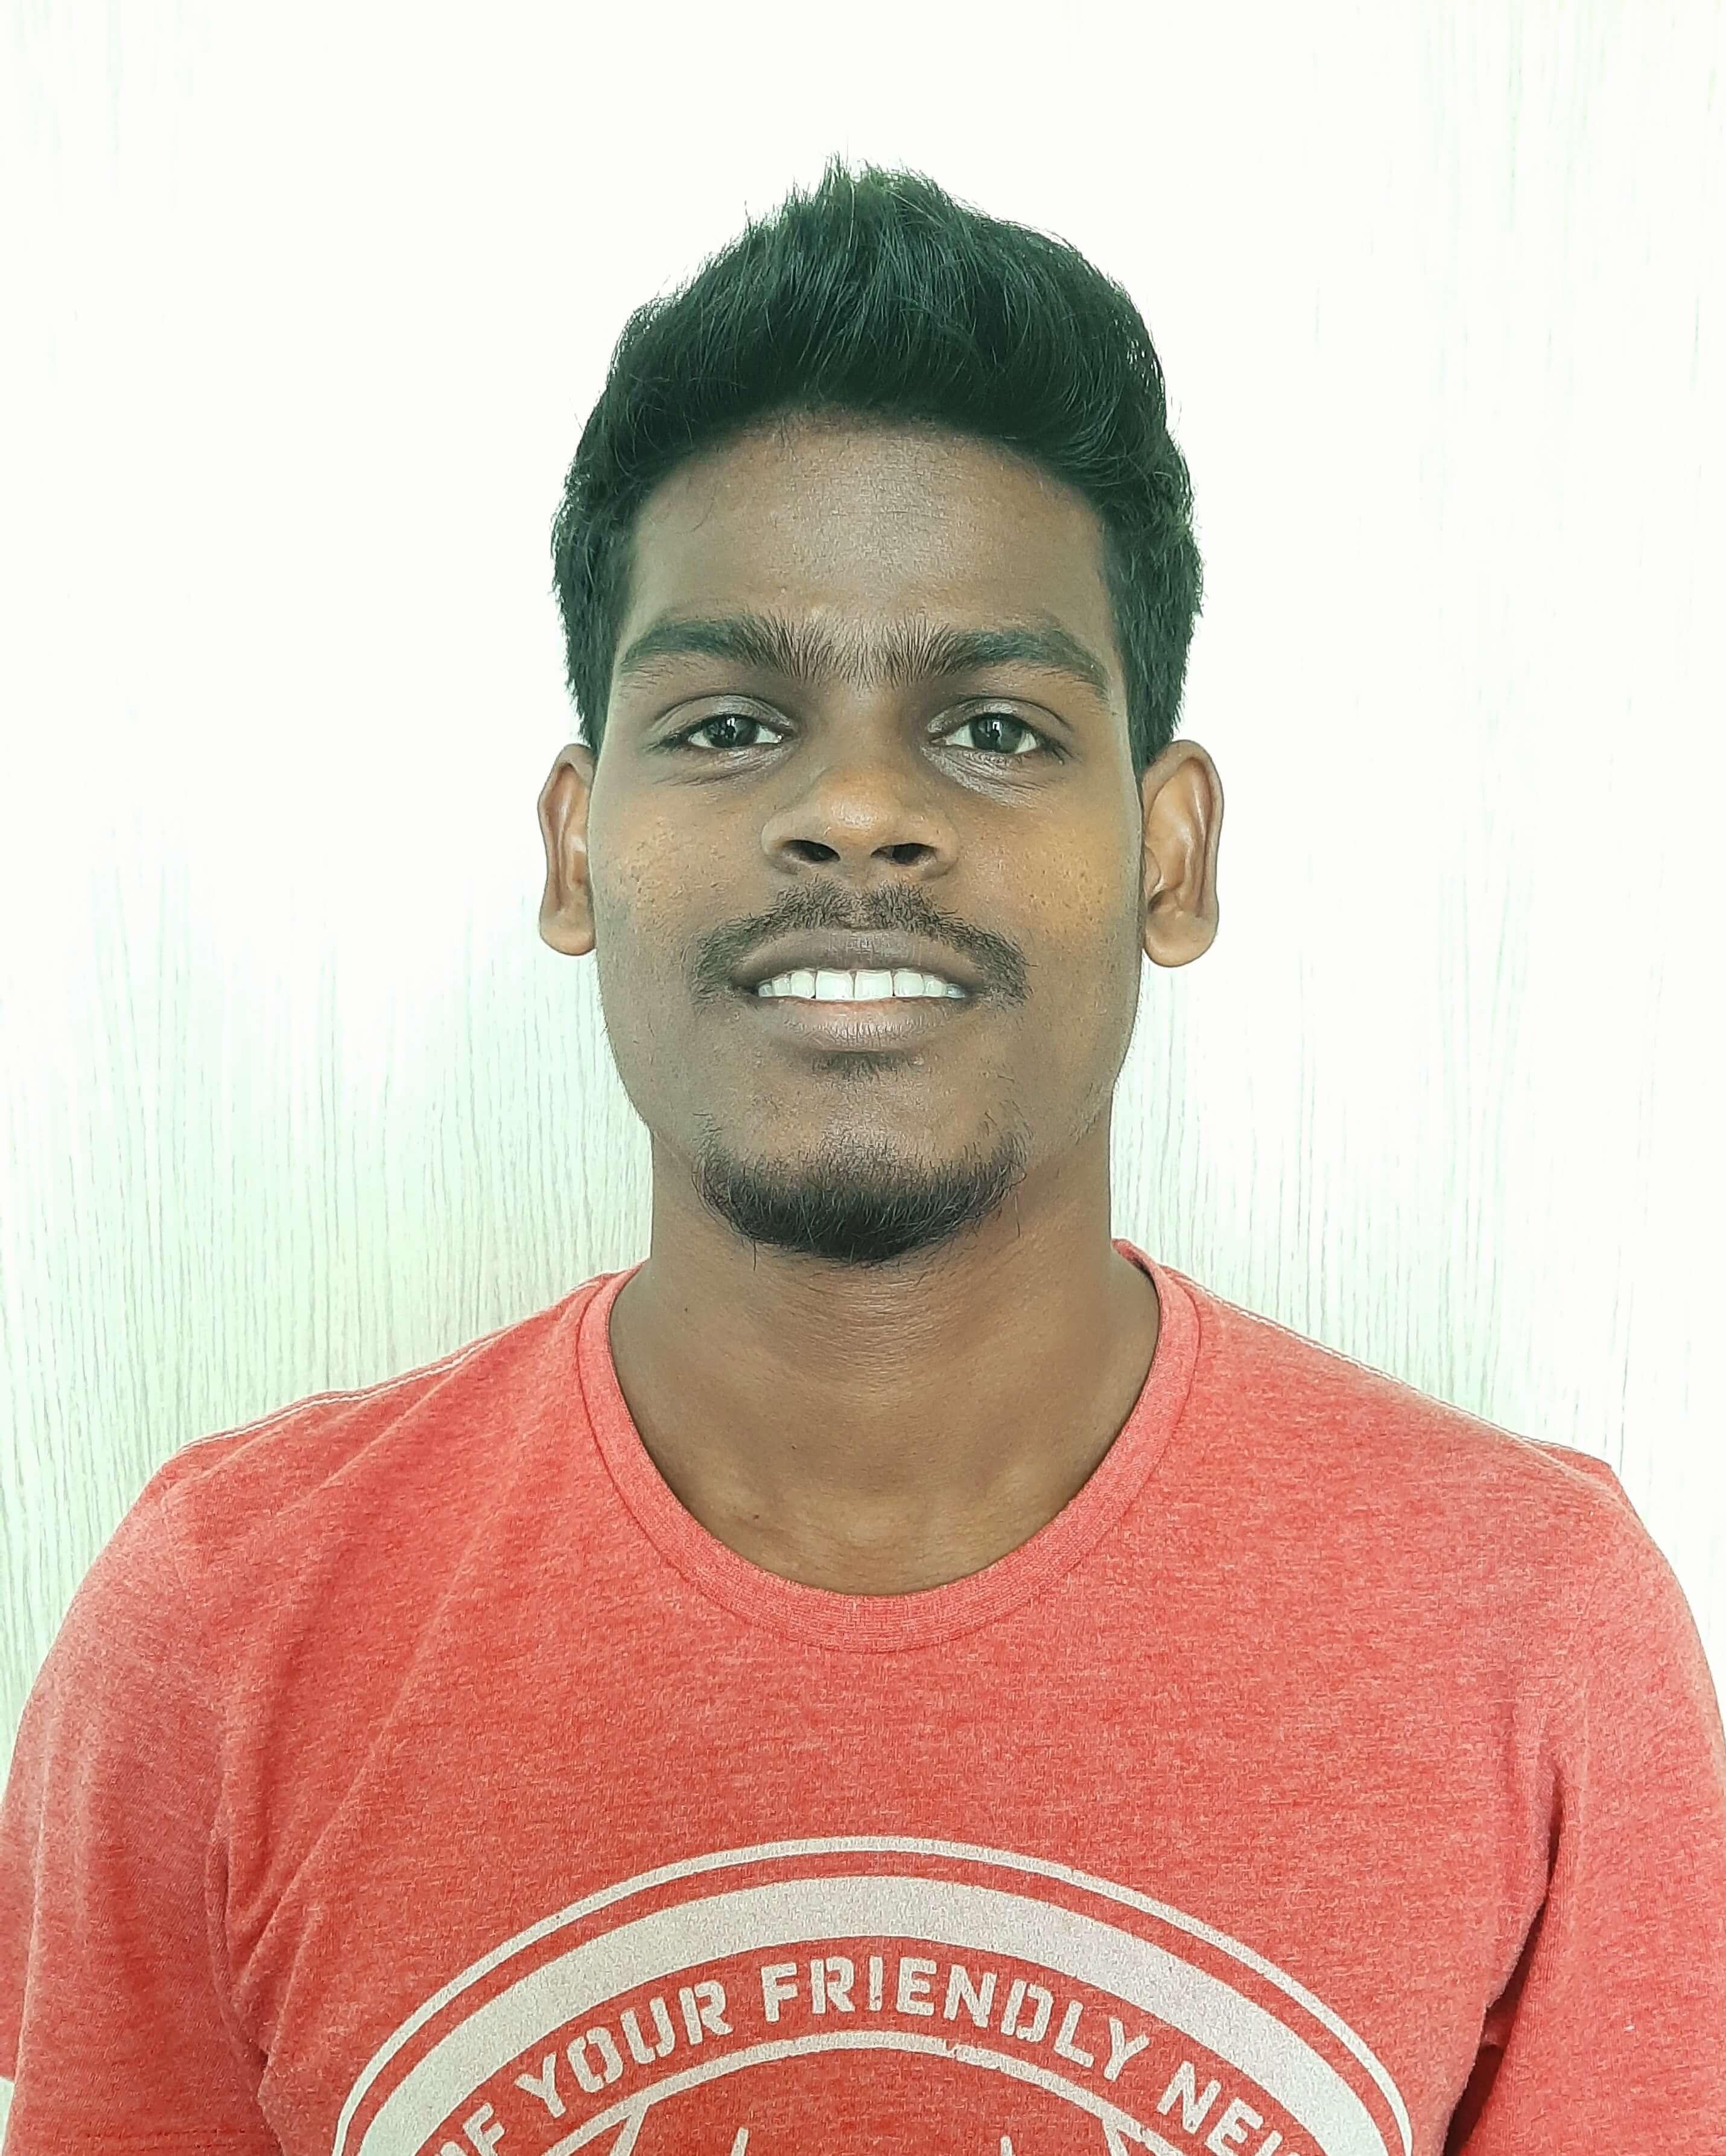

*Consultant, HCL Technologies*

**CAREER OBJECTIVE**

Intend to build a career with leading corporate of hi-tech environment with committed and dedicated people, which will help me to explore myself fully and realize my potential and willing to work as a key player in challenging and creative environment. Being hardworking & sincere, I am confident that I’ll make significant contribution to the organization I work with.

**Email :** [kamalswainbox@gmail.com](mailto:kamalswainbox@gmail.com)

kamal.swain@hotmail.com

**Number:** (+91) 8867760164, 8895180999

**SUMMARY**

* Sr UI Developer
* Experience – 8 years
* Experience in Aero domain
* Experience in Retail domain
* Experience in Health & Financial domain

**RELEVANT WORK EXPERIENCE**

Over 8 years of development experience which includes following

* Having strong knowledge and hands-on experience in **Angular**
* Good understanding about Angular Lificycles
* Good understanding about RxJS/Observables
* Good understanding about Angular Architecture
* Good experience in using various frameworks (Angular Material, Bootstrap )
* Having strong knowledge in Type Script and ES6
* Having strong knowledge in Object Oriented Programming
* Experience working in all phases of SDLC life cycle.
* Knowledge of Agile and Scrum methodologies.
* Working knowledge of Project Management Tool – TFS, VSTS, JIRA, Version One
* Working knowledge in version control system – GIT and SVN
* Experience in development with code standards
* Strong understanding of Model-View-Controller MVC pattern in development of Single Page Application SPA using Angular
* Good communication skills and leadership skills
* Flexible to and keen on learning new technologies / frameworks.
* Basic understanding in DevOps

**AGILE EXPERIENCE**

* Participate in SDLC (agile-scrum), Capacity planning, Sprint kick off, sprint development, retrospectives, design sessions, providing demo, testing, build readiness, and troubleshooting sessions.
* Daily stand-up meetings.
* Weekly Meetings with clients for demo.

**TECHNOLOGY SKILLS**

* Language: JavaScript, TypeScript , HTML5, CSS3, SCSS
* Frameworks : **Angular**, Angular JS, Bootstrap, Materialize, Express, jQuery
* SCM : GIT, SVN
* Build : Node JS , MongoDB
* Testing : Unit Testing Jasmine
* Web Services: Rest web services

**PERSONAL SKILLS**

* Proven leadership skills and ability to motivate.
* Strong Team Player
* Experience in design and development
* Experience in Agile teams
* Pro-active, responsible
* Strong analytical and problem solving skills

**EDUCATION**

* Bachelor of Arts(BA) from Utkal University, Bhubaneswar, Odisha.

**PERSONAL DETAILS**

* Gender: Male
* Nationality: Indian
* Passport Number: P2082626

TECHNOLOGY STACK 

**Framework :** Angular , MEAN Stack, Bootstrap, Angular Material

**Web Technology:** Angular,TypeScript,JavaScript,HTML, CSS, Bootstrap, ReactJS(poc)

**Programming Languages:** JavaScript, TypeScript

**API Development :** REST Web services

**Web/App Server:**  Node JS

**SCM:**  GIT , SVN

**IDE & Tools:** Eclipse, VS Code, Sublime Text

**NoSQL Database:** MongoDB

WORK EXPERIENCE 

**#0 Project :** Currency GUI Modernization

**Client :** FedEx

**Environment :** Angular, .Net micro service, Microsoft SQL, Azure Devops, Azure Cloud Service

**Team Size :** 9

**Duration :** 1 Year

**Description**: Currency UI application helps FedEx to create, convert, expire and mange the currency’s for logistics operations on different region .

**#1 Project :** PPD (Investigator Grant Forecasting)

**Client :** PPD

**Environment :** Angular, .Net micro service, Microsoft SQL, Azure Devops, Azure Cloud Service

**Team Size :** 25

**Duration :** 1 Year

**Description**: IGF is a tool that will enable the PPD to create, Manage the Financial Budget of Grant (Human Trial) and it will forecast the Month on Month accrual of cost and capable to track the financial impact on change in Grant Cost.

**Application Key features:**

**Budget**   
- This engine helps to Create, Modify the Budgeting of each trial design of a study  
- It will help to track the study at institution level and arrive the Cost per patient for a Trial Design  
- It also captures the site / institution related costs  
- It captures and manages the budget with different currencies  
**Assumption:**  
- Assumptions are the business factor that influence the budget / cost  
- It tracks all the factors with variable parameters to influence the budget  
- Like Screen failure, Drop-out Rate, Forecast & actual Patient Enrollment   
**Forecast:**  
- Based on change in assumption parameter, Grant Cost will be forecasted for future months  
- And it also calculated the financial risk in executing the study. Based on that Finance, will request for Contract Modification  
- It controls based on Financial period and for each financial period, forecasting the Grant cost and reported   
**Reporting:**  
- It has inbuild on-demand reporting feature  
- It also provides finance reporting on-demand for Finance team to accrue or book expense

**#2 Project :** eCFD

**Client :** The Boeing Company

**Environment :** Angular, Java, Python, REST Services, MongoDB

**Team Size :** 20

**Duration :** 9 months

**Description**: Working in self-service portal (eCFD – Enterprise Computational Fluid Dynamics) for the engineering team of The Boeing Company. Business user would create a process specification by choosing what process features they want, specifying steps within the process, input and output data for each step, which user or group is to work on it, user interface specification to capture/present information to user. Based on the process specification IT platform automatically generates necessary components and configures itself to support the new process. Immediately after the process is published, users can potentially use this new process definition to create instances of it and start work right away

**#3 Project :** AIREIS

**Client :** The Boeing Company.

**Environment** : Angular, Bootstrap, Java, REST Services, Python, MongoDB

**Team Size :** 5

**Duration :** 7 months

**Description**: The application basically accepts the problem statements reported by customer and highlights the problems of specific parts/areas of an aircraft in image form using word cloud image generator. This problem statement will parse with semantic analysis tool to generate words and its weightage. These words and its weightage further used to train LSA module. So, words will show in image with different color and size according to its weightage

**#4 Project : Dineout**

**Client :** Times Group.

**Environment** **:** Angular, NodeJS, REST Services, MongoDB

**Team Size :** 15

**Duration :** 1.8 months

**Description**: Inresto(Dineout) is a comprehensive Restaurant Management System which boost up the restaurant business to the next level with online food ordering system, branded mobile apps & Table booking platform.

Testimony

Kamal Kumar Swain

Consultant

Phone: +91 8867760164 / 8895180999

Email : [kamalswainbox@gmail.com](mailto:kamalswainbox@gmail.com)

kamal.swain@hotmail.com